A new process for studying proteins associated with diseases

September 17, 2015
Could pave the way for new drugs for a myriad of diseases, including cancer
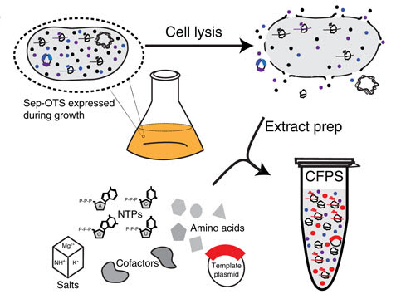
Schematic of phosphoprotein biosynthesis from E. coli bacteria. Sep-OTS: genetically encoded phosphoserine; CFPS: cell-free protein synthesis; NTPs: nucleoside triphosphates; lysis: breaking down cell membrane.
Researchers from Northwestern University and Yale University have developed a new technology to help scientists understand how proteins work and fix them when they are broken. Such knowledge could pave the way for new drugs for a myriad of diseases, including cancer.
The human body turns its proteins on and off (to alter their function and activity in cells) using “phosphorylation” — the reversible attachment of phosphate groups to proteins. These “decorations” on proteins provide an enormous variety of functions and are essential to all forms of life. Little is known, however, about how this important dynamic process works in humans.
Phosphorylation: a hallmark of disease
Using a special strain of E. coli bacteria, the researchers built a cell-free protein synthesis platform technology that can manufacture large quantities of these human phosphoproteins for scientific study. The goal is to enable scientists to learn more about the function and structure of phosphoproteins and identify which ones are involved in disease.
The study was published Sept. 9 in an open-access paper by the journal Nature Communications.
Trouble in the phosphorylation process can be a hallmark of disease, such as cancer, inflammation and Alzheimer’s disease. The human proteome (the entire set of expressed proteins) is estimated to be phosphorylated at more than 100,000 unique sites, making study of phosphorylated proteins and their role in disease a daunting task.
“Our technology begins to make this a tractable problem,” said Michael C. Jewett, an associate professor of chemical and biological engineering who led the Northwestern team. “We now can make these special proteins at unprecedented yields, with a freedom of design that is not possible in living organisms. The consequence of this innovative strategy is enormous.”
A “plug-and-play” protein expression platform
Jewett and his colleagues combined state-of-the-art genome engineering tools and engineered biological “parts” into a “plug-and-play” protein expression platform that is cell-free. Cell-free systems activate complex biological systems without using living intact cells. Crude cell lysates, or extracts, are employed instead.
The researchers prepared cell lysates of genomically recoded bacteria that incorporate amino acids not found in nature. This allowed them to harness the cell’s engineered machinery and turn it into a factory, capable of on-demand biomanufacturing new classes of proteins.
To demonstrate their cell-free platform technology, the researchers produced a human kinase that is involved in tumor cell proliferation and showed that it was functional and active. Kinase is an enzyme (a protein acting as a catalyst) that transfers a phosphate group onto a protein. Through this process, kinases activate the function of proteins within the cell. Kinases are implicated in many diseases and, therefore, of particular interest.
“The ability to produce kinases for study should be useful in learning how these proteins function and in developing new types of drugs,” Jewett said.

Abstract of Robust production of recombinant phosphoproteins using cell-free protein synthesis
Understanding the functional and structural consequences of site-specific protein phosphorylation has remained limited by our inability to produce phosphoproteins at high yields. Here we address this limitation by developing a cell-free protein synthesis (CFPS) platform that employs crude extracts from a genomically recoded strain of Escherichia coli for site-specific, co-translational incorporation of phosphoserine into proteins. We apply this system to the robust production of up to milligram quantities of human MEK1 kinase. Then, we recapitulate a physiological signalling cascade in vitro to evaluate the contributions of site-specific phosphorylation of mono- and doubly phosphorylated forms on MEK1 activity. We discover that only one phosphorylation event is necessary and sufficient for MEK1 activity. Our work sets the stage for using CFPS as a rapid high-throughput technology platform for direct expression of programmable phosphoproteins containing multiple phosphorylated residues. This work will facilitate study of phosphorylation-dependent structure–function relationships, kinase signalling networks and kinase inhibitor drugs.

references:
- Javin P. Oza, Hans R. Aerni, Natasha L. Pirman, Karl W. Barber, Charlotte M. ter Haar, Svetlana Rogulina, Matthew B. Amrofell, Farren J. Isaacs, Jesse Rinehart, Michael C. Jewett. Robust production of recombinant phosphoproteins using cell-free protein synthesis. Nature Communications, 2015; 6: 8168 DOI: 10.1038/ncomms9168 (open access)

